199. Binary Tree Right Side View
Medium

Given the root of a binary tree, imagine yourself standing on the right side of it, return the values of the nodes you can see ordered from top to bottom.

Example 1:
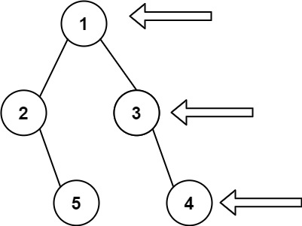
Input: root = [1,2,3,null,5,null,4]
Output: [1,3,4]
Example 2:
Input: root = [1,null,3]
Output: [1,3]
Example 3:
Input: root = []
Output: []

Constraints:
- The number of nodes in the tree is in the range [0, 100].
- -100 <= Node.val <= 100

